Project Design Phase-II Technology Stack (Architecture & Stack)

|  |  |
| --- | --- |
| Date | 10/11/2023 |
| Team ID | Amil Anilkumar |
| Project Name | Potato leaf Disease Identification |
| Maximum Marks | 4 Marks |

Technical Architecture:

Guidelines:

1. Include all the processes (As an application logic / Technology Block)
2. Provide infrastructural demarcation (Local / Cloud)
3. Indicate external interfaces (third party API’s etc.)
4. Indicate Data Storage components / services
5. Indicate interface to machine learning models (if applicable)

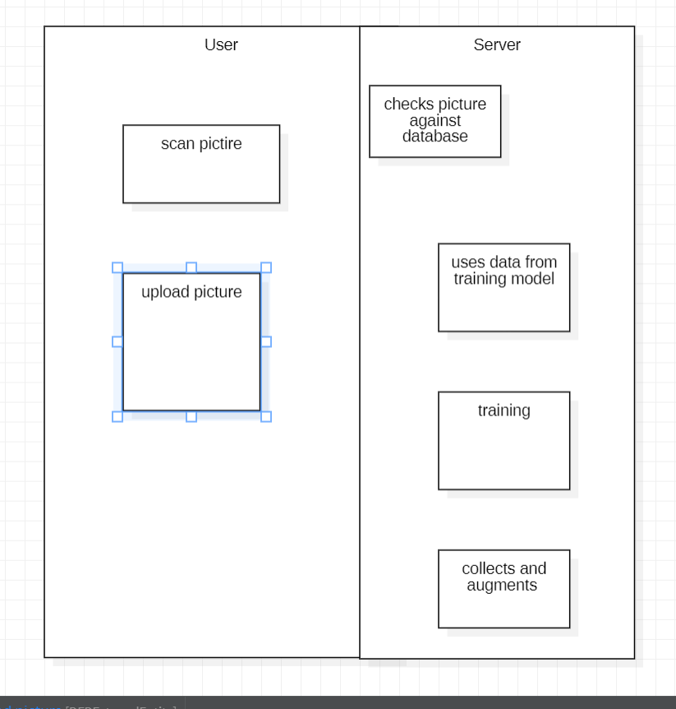

Table-1 : Components & Technologies:

|  |  |  |  |
| --- | --- | --- | --- |
| **S.No** | **Component** | **Description** | **Technology** |
| 1. | User Interface | How user interacts with application - Web UI | Python |
| 2. | Application Logic-1 | Logic for the process in the application | Python |

Table-2: Application Characteristics:

|  |  |  |  |
| --- | --- | --- | --- |
| **S.No** | **Characteristics** | **Description** | **Technology** |
| 1. | Libraries, APIs | List the open-source frameworks used | Tensorflow, matplotlib |

|  |  |  |  |
| --- | --- | --- | --- |
| **S.No** | **Characteristics** | **Description** | **Technology** |
| 4. | Availability | Justify the availability of application (e.g. use of load balancers, distributed servers etc.) | Technology used |
| 5. | Performance | Design consideration for the performance of the application (number of requests per sec, use of  Cache, use of CDN’s) etc. | Technology used |

References:

<https://c4model.com/>

<https://developer.ibm.com/patterns/online-order-processing-system-during-pandemic/> <https://www.ibm.com/cloud/architecture>

<https://aws.amazon.com/architecture>

<https://medium.com/the-internal-startup/how-to-draw-useful-technical-architecture-diagrams-2d20c9fda90d>